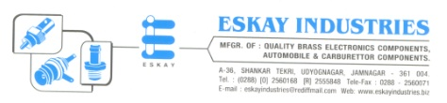

CERTIFICATE
To whomever it may concern

This is to certify that the project report compiled by Mr. Doshi Keyur student of the 8th Sem. Computer engineering in C.U.Shah College of Engineering & Technology,Wadhawan City, has completed his 8th Semester project satisfactorily. To the best of our knowledge this is original work done by him. He has work on “INVENTORY MANAGEMENT SYSTEM” using .NET Technology. He was found to be very sincere and hardworking in his assigned work. I wish him best of luck for bright future.

Best Regards,
ESKAY INDUSTRIES,
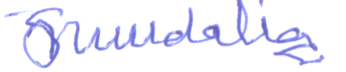
(Satish M. Kundalia)

